William Pineda

143089

PJM530

1. Project Schedule Showing Dependencies

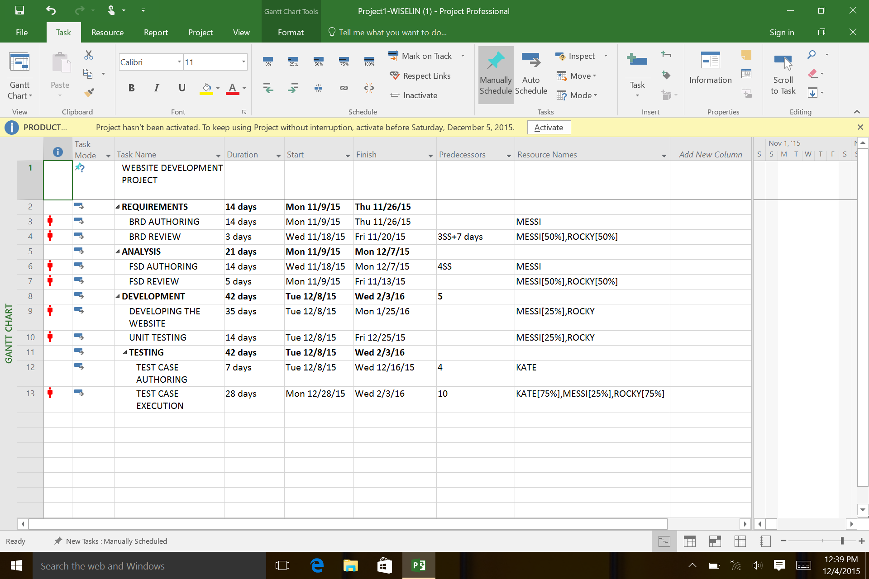

1. Gantt Chart

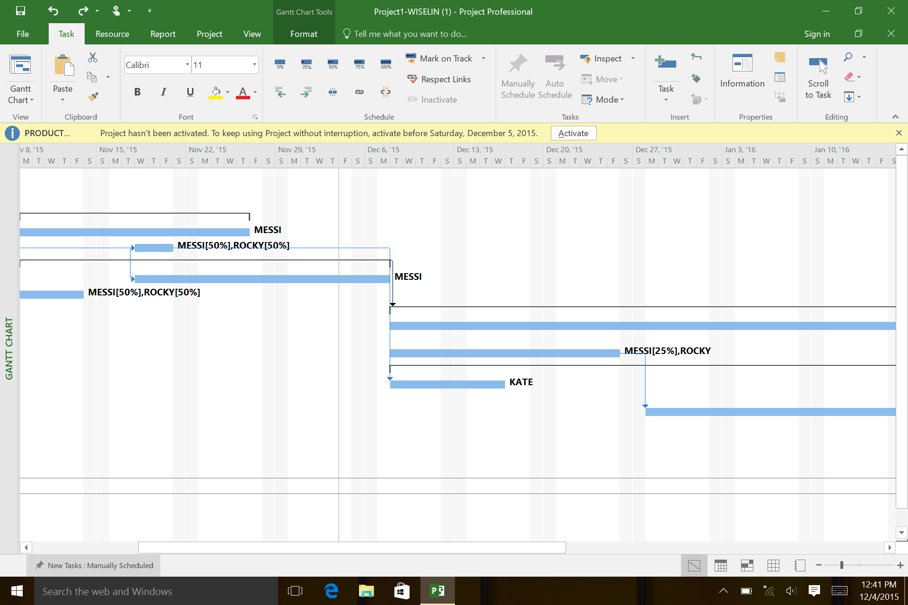

1. Critical Path

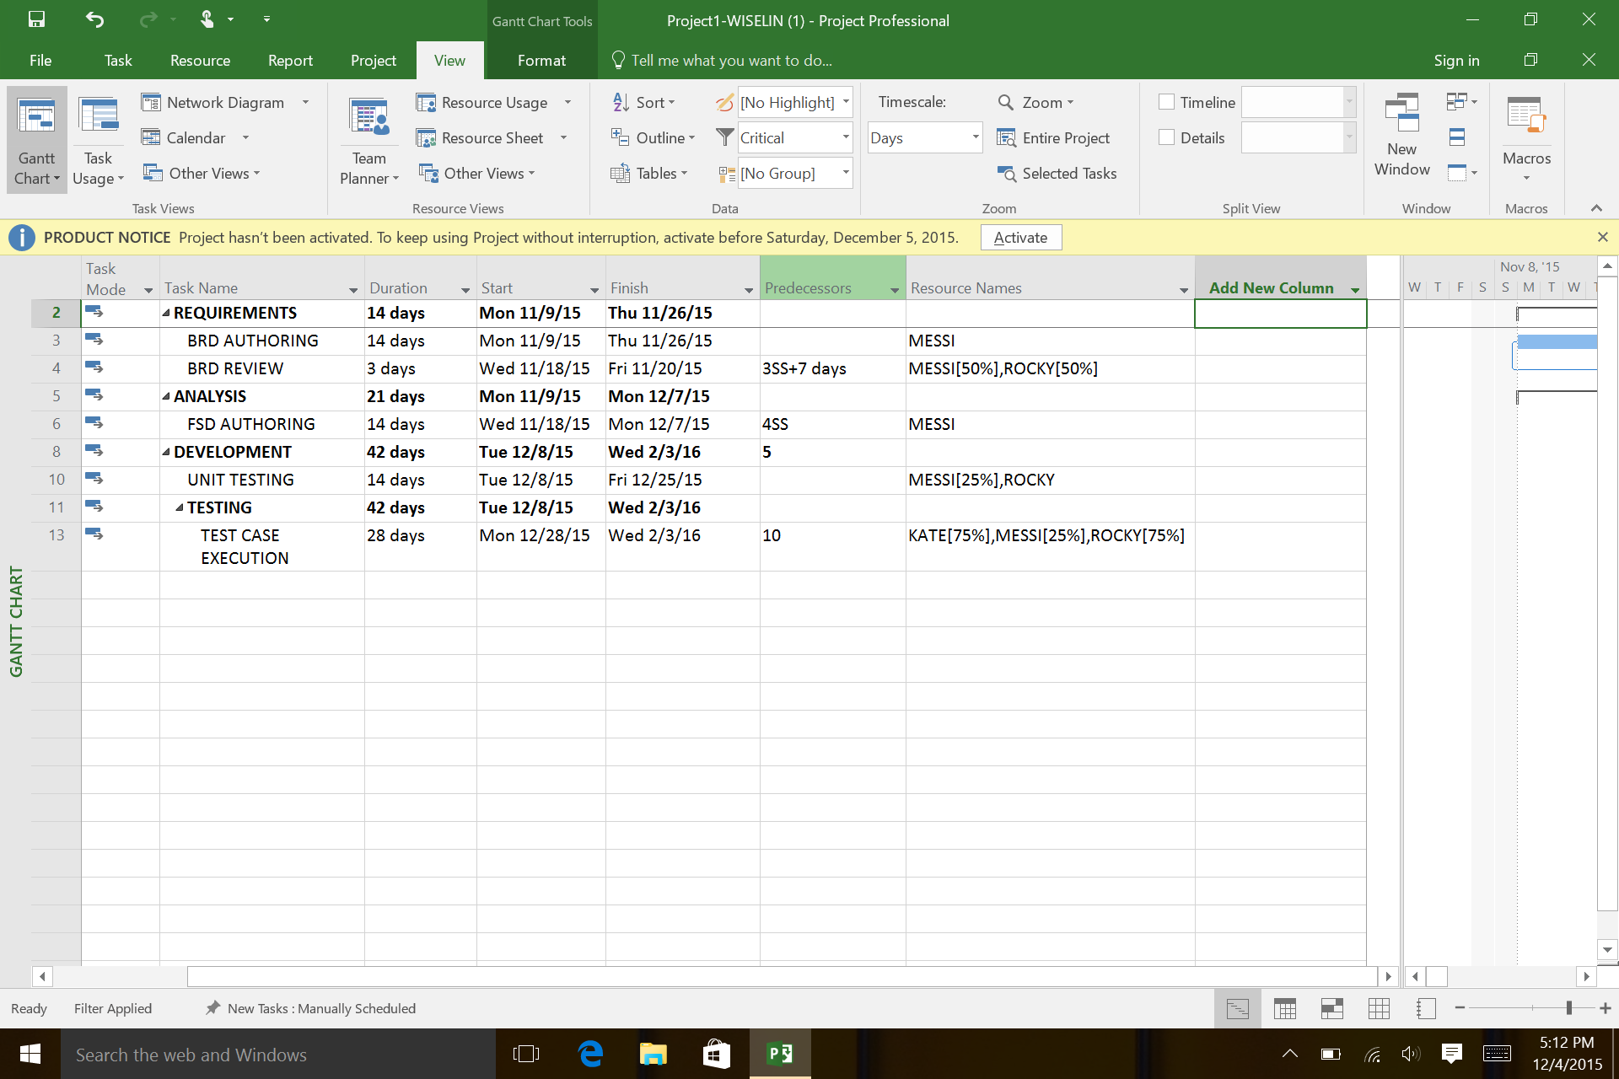

1. Before Applying Resource Level

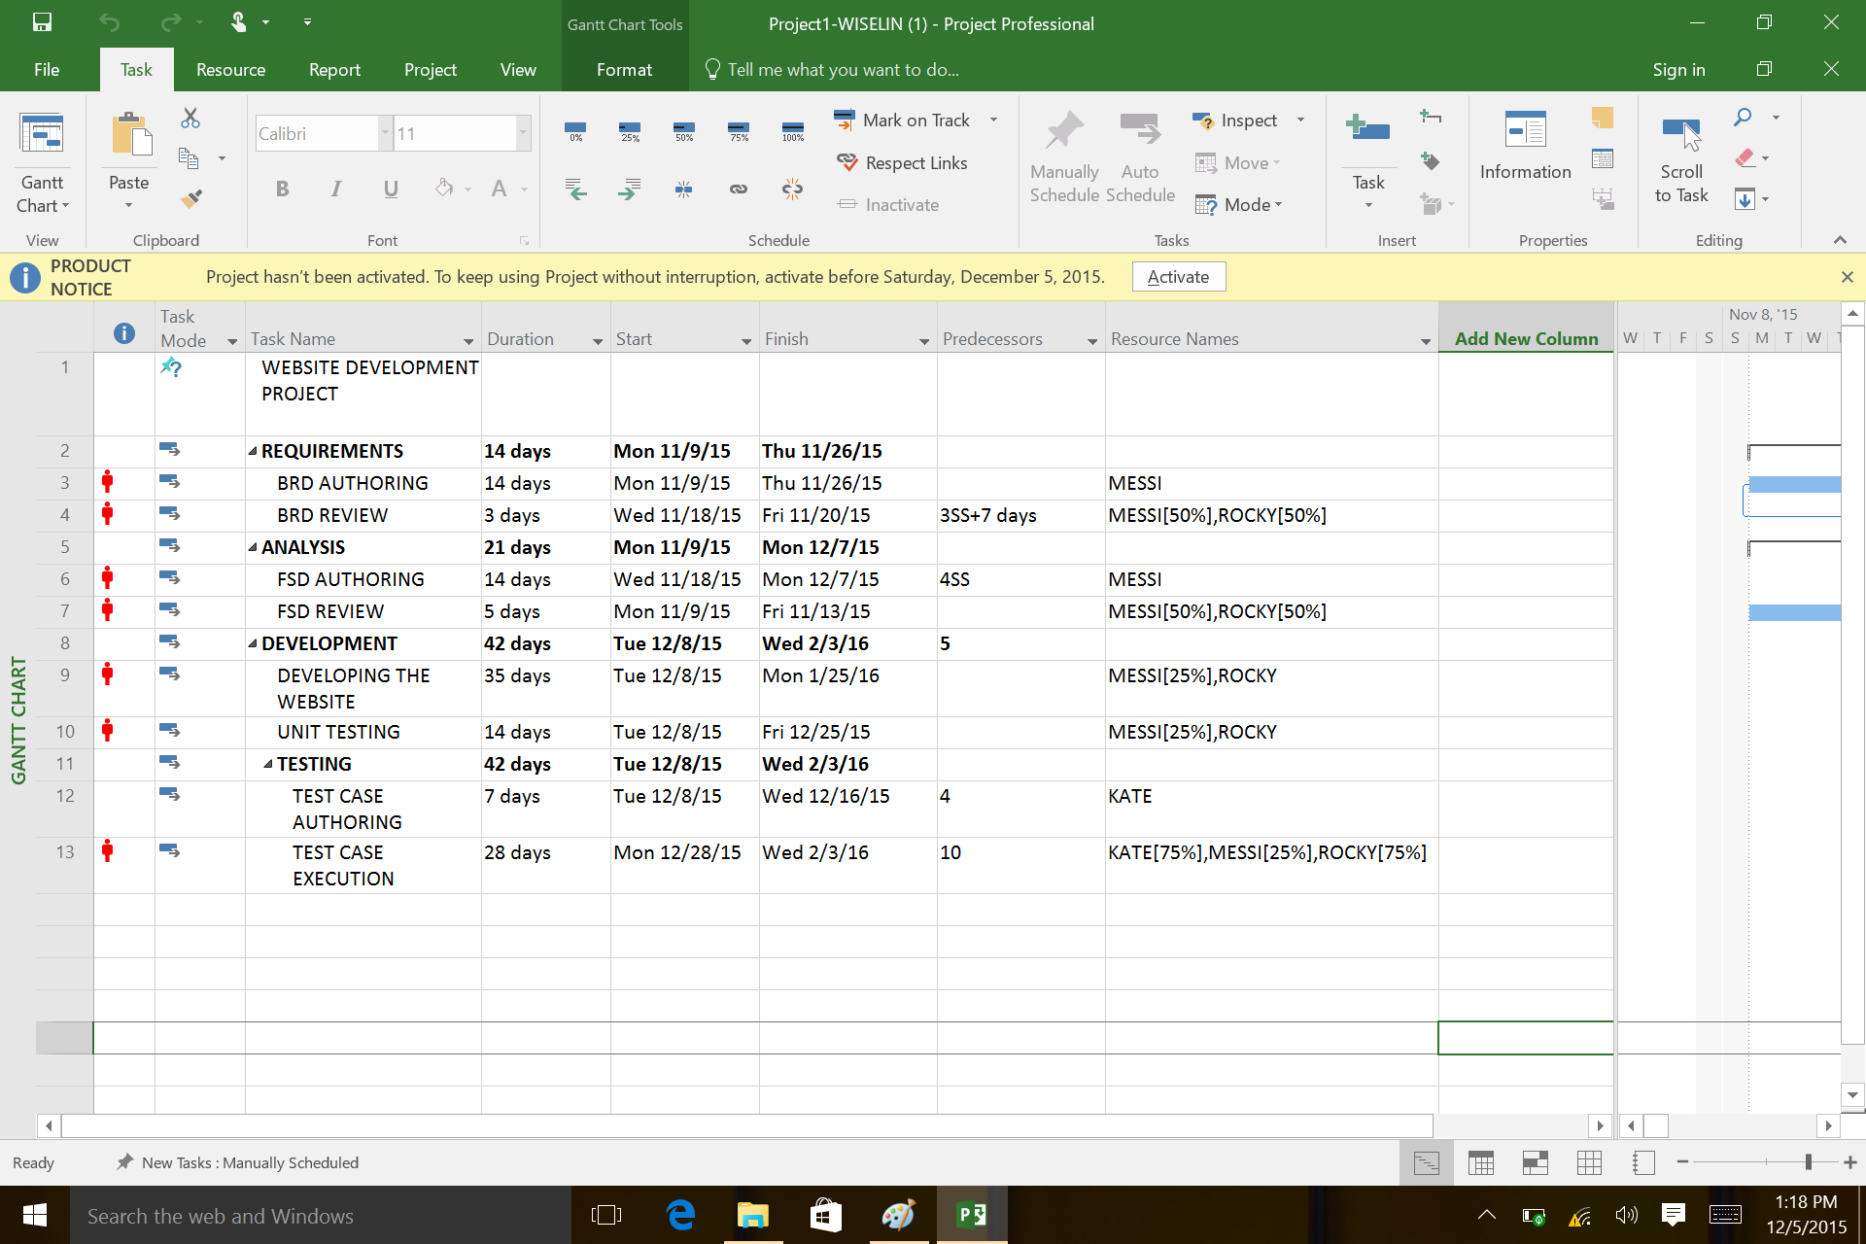

* 1. After Resource Leveling

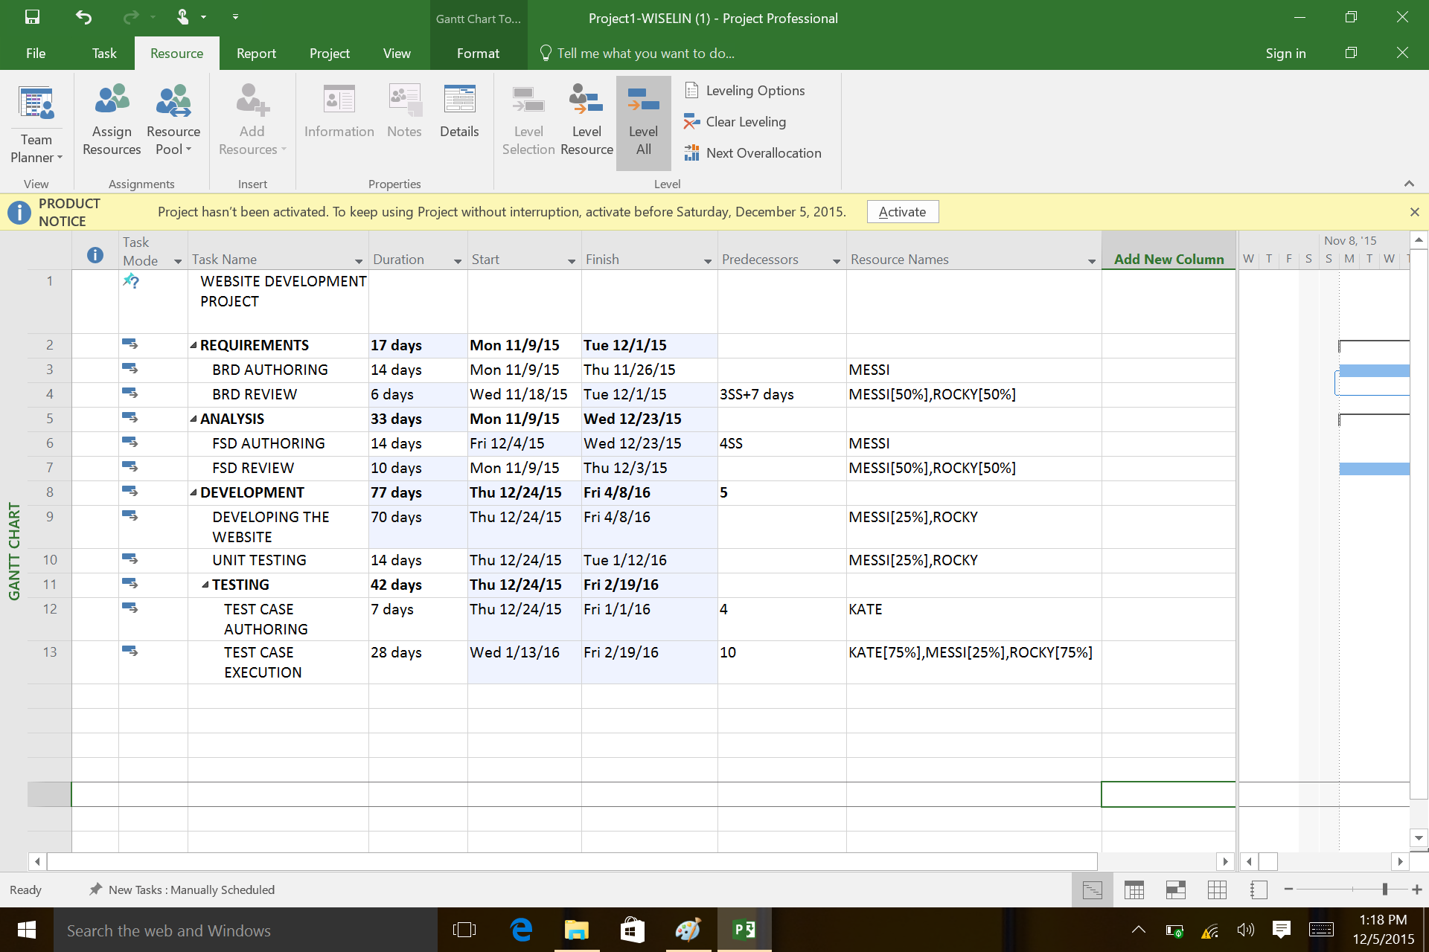

1. Project Baselining

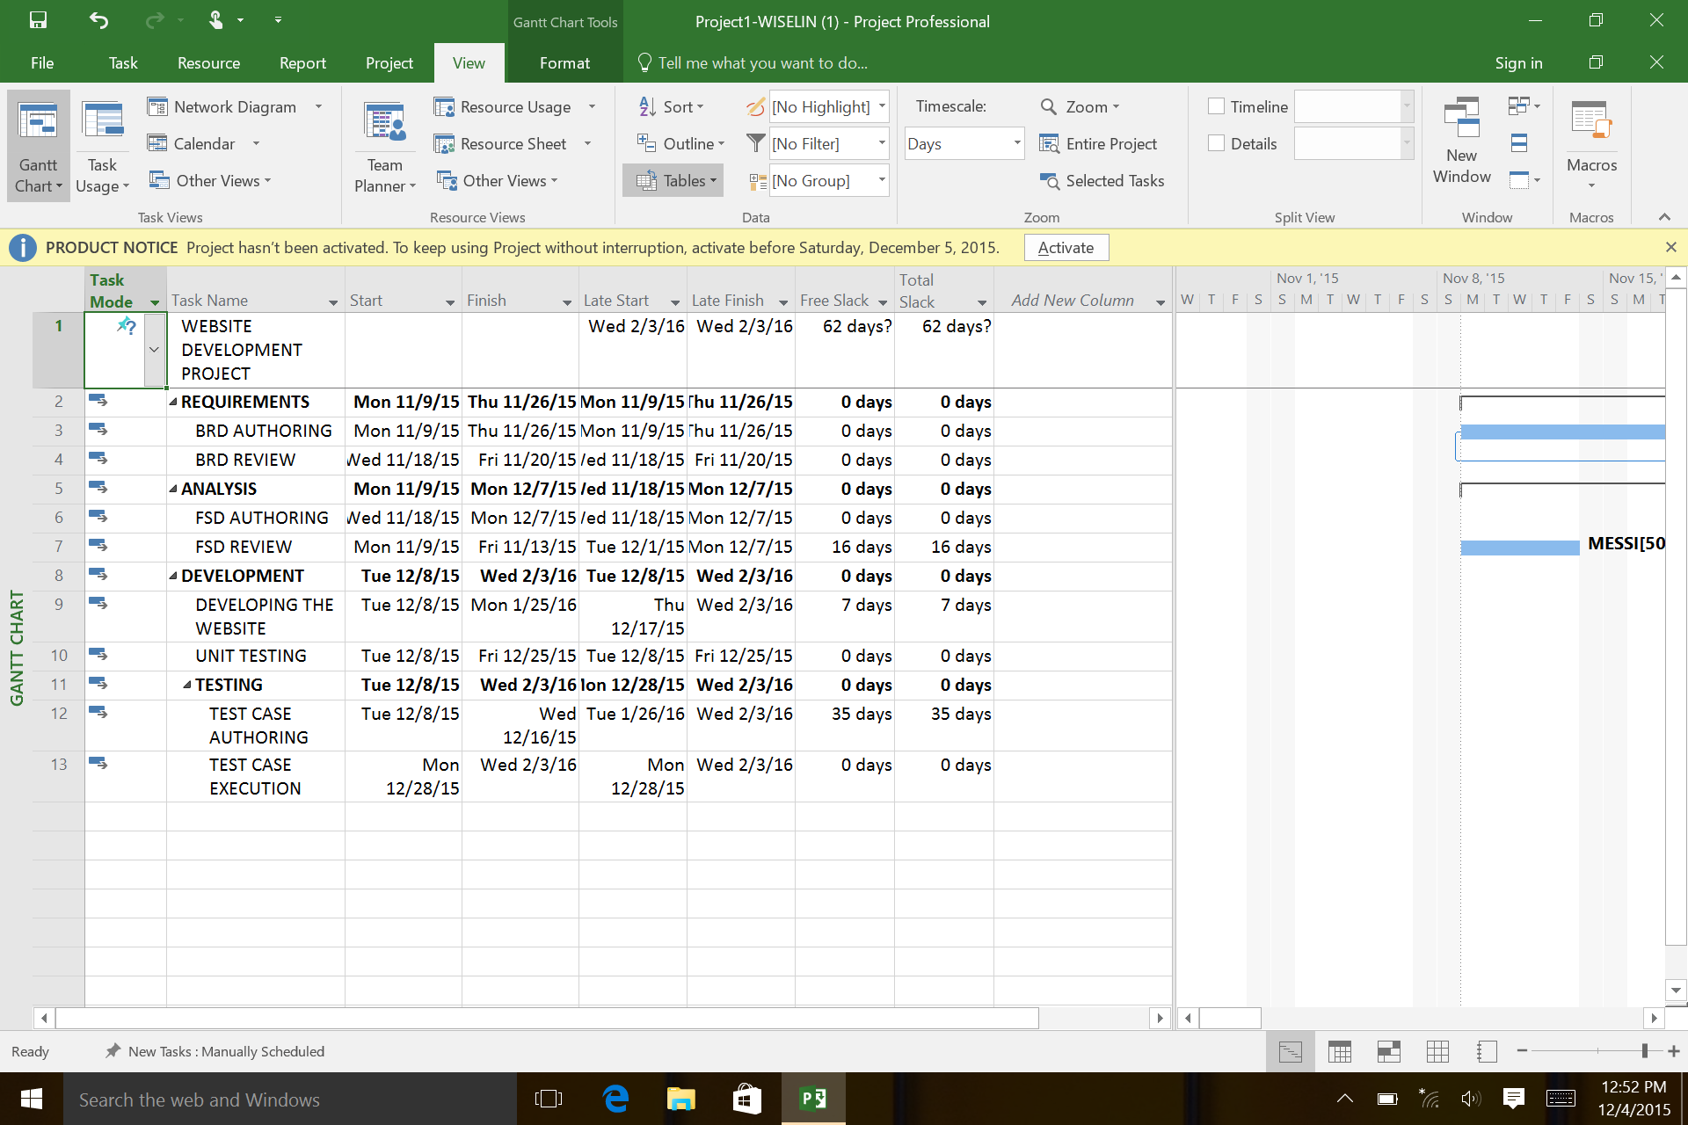

1. Earned Value Cost Indicators

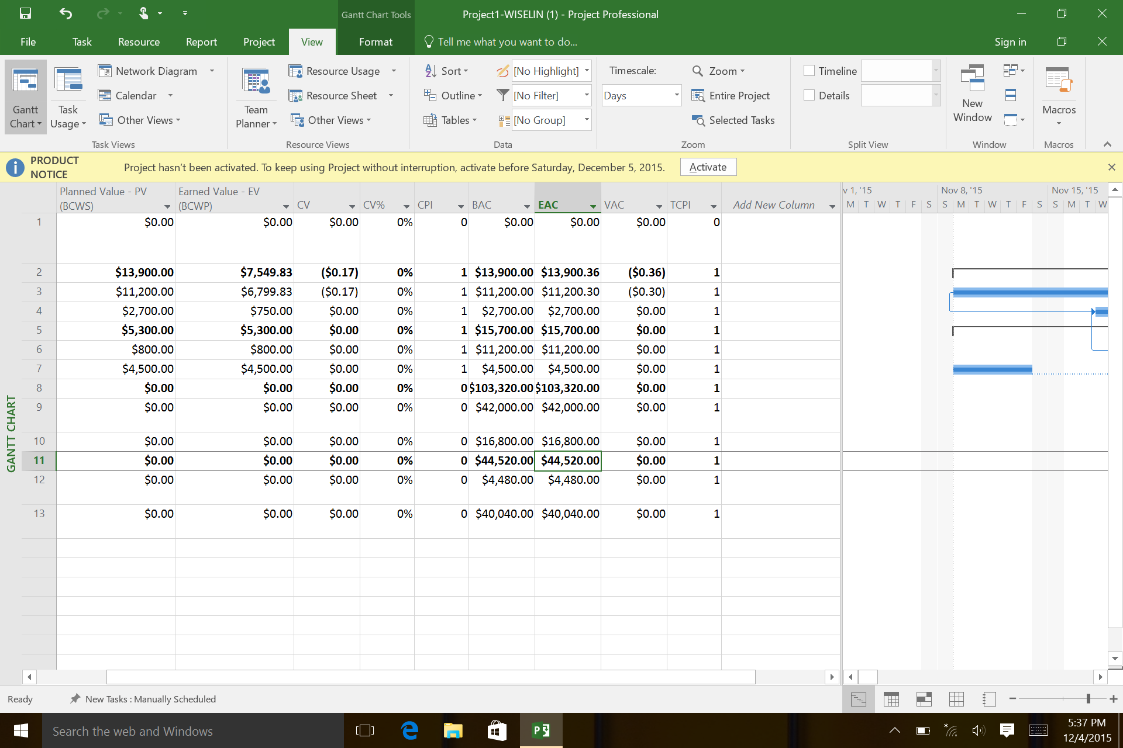

1. Earned Value Schedule Indicators

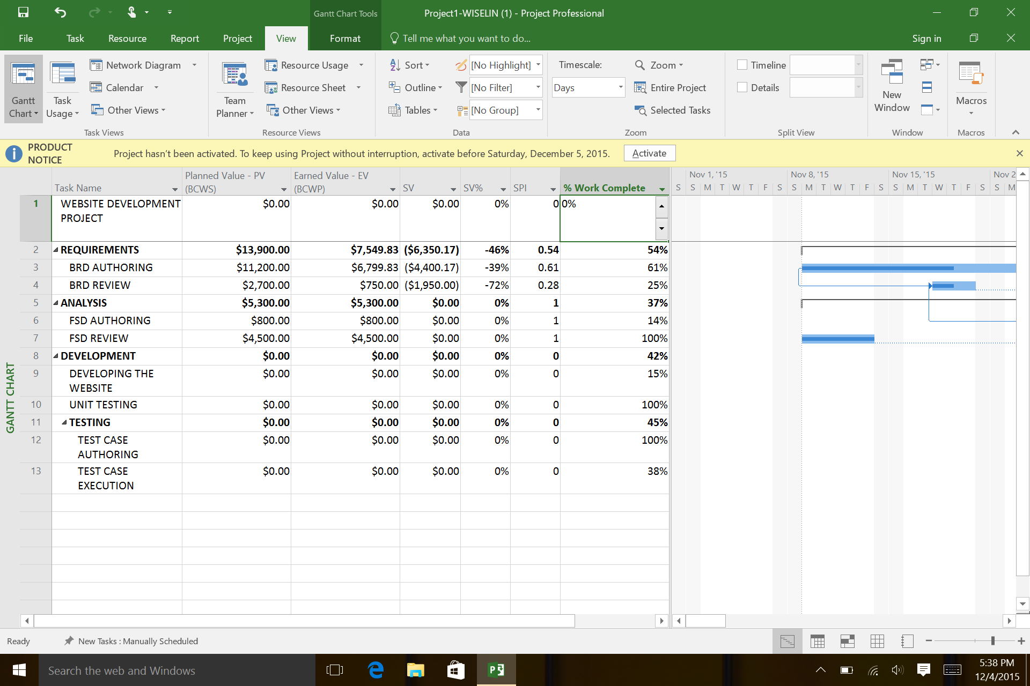

1. Showing Slack

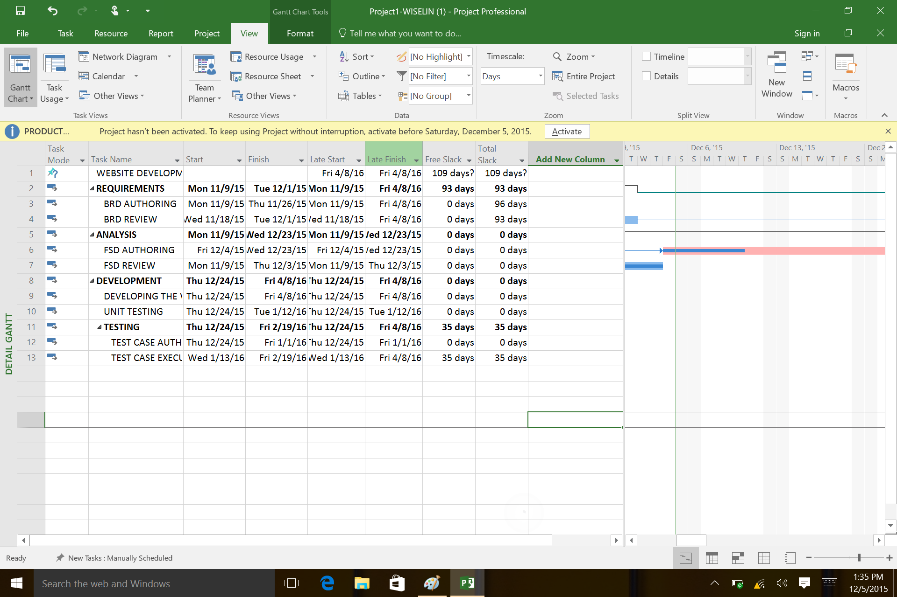

1. Adding a Milestone

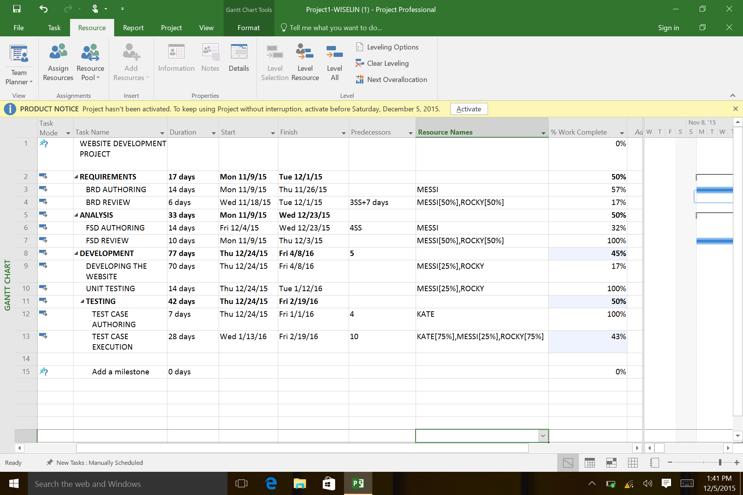

1. (optional
2. Timeline to copy into a presentation

Start  
Mon 11/9/15

Finish  
Fri 4/8/16

Nov 22, '15

Dec 6, '15

Dec 20, '15

Jan 3, '16

Jan 17, '16

Jan 31, '16

Feb 14, '16

Feb 28, '16

Mar 13, '16

Mar 27, '16

**Today**

Budget

|  |  |  |  |  |  |  |  |
| --- | --- | --- | --- | --- | --- | --- | --- |
| Task Name | Fixed Cost | Fixed Cost Accrual | Total Cost | Baseline | Variance | Actual | Remaining |
| **Project1-WISELIN** | **$0.00** | **Prorated** | **$132,920.00** | **$0.00** | **$132,920.00** | **$15,000.00** | **$117,920.00** |